PRANAV RAIKAR

D15A 47

Aim: To install and configure the Flutter Environment

Theory: Flutter is an open source framework by Google for building beautiful, natively compiled, multi-platform applications from a single codebase. Fast: Flutter code compiles to ARM or Intel machine code as well as JavaScript, for fast performance on any device. Productive: Build and iterate quickly with Hot Reload. Update code and see changes almost instantly, without losing state. Flexible: Control every pixel to create customized, adaptive designs that look and feel great on any screen. Android Studio is the official integrated development environment (IDE) for Google's Android operating system, built on JetBrains' IntelliJ IDEA software and designed specifically for Android development. It is available for download on Windows, macOS and Linux based operating systems. It is a replacement for the Eclipse Android Development Tools (E-ADT) as the primary IDE for native Android application development.

Install the Flutter SDK

Step 1: Download the installation bundle of the Flutter Software Development Kit for windows.

To download Flutter SDK, Go to its official website https://docs.flutter.dev/get-started/install ,

you will get the following screen.

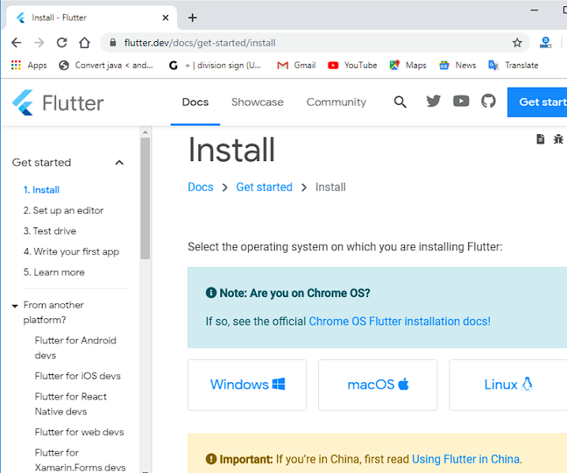

Step 2: Next, to download the latest Flutter SDK, click on the Windows icon. Here, you will

find the download link for SDK.

Step 3: When your download is complete, extract the zip file and place it in the desired

installation folder or location, for example, C: /Flutter.

Step 4: To run the Flutter command in regular windows console, you need to update the system

path to include the flutter bin directory. The following steps are required to do this:

Step 4.1: Go to MyComputer properties -> advanced tab -> environment variables. You will get

the following screen.

Step 4.2: Now, select path -> click on edit. The following screen appears

Step 4.3: In the above window, click on New->write path of Flutter bin folder in variable value -

> ok -> ok -> ok.

Step 6: When you run the above command, it will analyze the system and show its report, as

shown in the below image. Here, you will find the details of all missing tools, which required to

run Flutter as well as the development tools that are available but not connected with the device.

Step 7: Install the Android SDK. If the flutter doctor command does not find the Android SDK

tool in your system, then you need first to install the Android Studio IDE. To install Android

Studio IDE, do the following steps.

Step 7.1: Download the latest Android Studio executable or zip file from the official site.

Step 7.2: When the download is complete, open the .exe file and run it. You will get the

following dialog box.

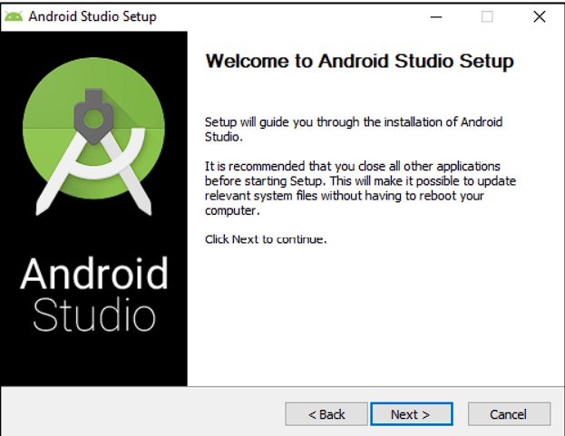

Step 7.3: Follow the steps of the installation wizard. Once the installation wizard completes, you

will get the following screen.

Step 7.4: In the above screen, click Next-> Finish. Once the Finish button is clicked, you need to

choose the 'Don't import Settings option’ and click OK. It will start the Android Studio.

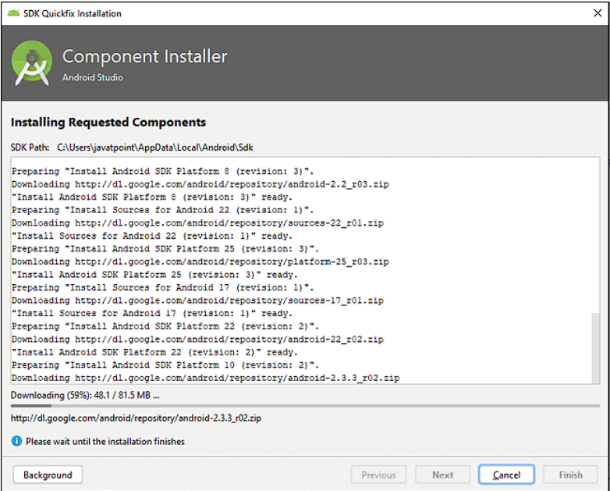

Step 7.5 run the $ flutter doctor command and Run flutter doctor --android-licenses command.

Step 8: Next, you need to set up an Android emulator. It is responsible for running and testing

the Flutter application.

Step 8.1: To set an Android emulator, go to Android Studio > Tools > Android > AVD Manager

and select Create Virtual Device. Or, go to Help->Find Action->Type Emulator in the search

box. You will get the following screen.

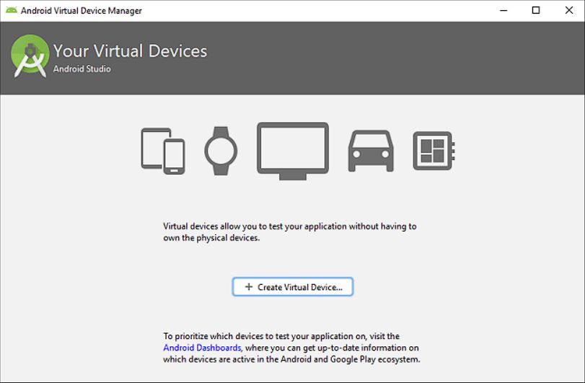

Step 8.2: Choose your device definition and click on Next.

Step 8.3: Select the system image for the latest Android version and click on Next.

Step 8.4: Now, verify the all AVD configuration. If it is correct, click on Finish. The following

screen appears.

Step 8.5: Last, click on the icon pointed into the red color rectangle. The Android emulator

displayed as below screen.

Step 9: Now, install Flutter and Dart plugin for building Flutter application in Android Studio.

These plugins provide a template to create a Flutter application, give an option to run and debug

Flutter application in the Android Studio itself. Do the following steps to install these plugins.

Step 9.1: Open the Android Studio and then go to File->Settings->Plugins.

Step 9.2: Now, search the Flutter plugin. If found, select Flutter plugin and click install. When

you click on install, it will ask you to install Dart plugin as below screen. Click yes to proceed.

